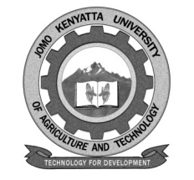
W1-2-60-1-6

JOMO KENYATTA UNIVERSITY OF AGRICULTURE AND TECHNOLOGY

UNIVERSITY EXAMINATIONS 2020/2021

YEAR IV SPECIAL/SUPPLEMENTARY EXAMINATION FOR THE DEGREE OF BACHELOR OF SCIENCE IN NUTRACEUTICAL SCIENCE AND TECHNOLOGY

AFS 2412: FRUITS, VEGETABLES AND CONFECTIONERY TECHNOLOGY

DATE: AUGUST 2021 TIME: 2 HOURS

INSTRUCTIONS: ANSWER ALL QUESTIONS I N SECTION A (COMPULSORY) AND ANY OTHER TWO QUESTIONS IN SECTION B

SECTION A

1. Describe the washing and cleaning operation as a component of fruits and vegetables. (6 marks)

2. Describe the steps involved in the manufacture of toffees. (6 marks)

3. Explain the health-promoting properties of flavonoids. (6 marks)

4. Explain the essential features of controlled atmosphere facilities for fruits.
(6 marks)

5. Explain the changes that occur in the cocoa bean during the roasting stage.
(6 marks)

SECTION B

6. Discuss the health-promoting properties of vitamin C. (20 marks)

7. Discuss turgor in plant cells and how it influences the texture and appearance of fruits and vegetables. (20 marks)

8. Discuss the various types of tea and how they are manufactured. (20 marks)

