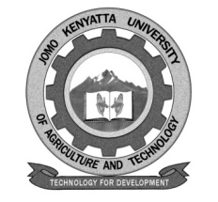
W1-2-60-1-6

JOMO KENYATTA UNIVERSITY OF AGRICULTURE AND TECHNOLOGY

UNIVERSITY EXAMINATIONS 2020/2021

YEAR IV FIRST SEMESTER EXAMINATION FOR THE DEGREE OF BACHELOR OF SCIENCE IN FOOD SCIENCE AND TECHNOLOGY

AFS 2406: INDUSTRIAL TRANSFORMATION OF CEREALS

DATE: AUGUST 2021 TIME: 2 HOURS

INSTRUCTIONS: ANSWER ALL QUESTIONS IN SECTION A (COMPULSORY) AND ANY OTHER TWO QUESTIONS IN SECTION B

SECTION A: 30 MARKS

1. Explain the selection and blending of the major streams of flour to produce the commercial grades of wheat flour with the aid of a labeled chart. (6 marks)

2. Explain the concepts of optimum ripening and fermentation tolerance in the bread making process. (6 marks)

3. State the functions of each of the following ingredients in cake making.
(6 marks)
a. Leavening

b. Shortening

4. Describe the traditional process for the manufacture of corn flakes. (6 marks)

5. Explain the tradition process for the manufacture of pasta. (6 marks)

SECTION B: 40 MARKS

6. Describe the manufacture of bread using a 3-hour bulk fermentation process by the straight-dough method. (20 marks)

7. Discuss the negative nutritional effects of the presence of phytates and tannins in cereals and cereal-based products. (20 marks)

8. Discuss the principal features of rice conversion processes and their consequence on the physical and sensory characteristics of the rice. (20 marks)

